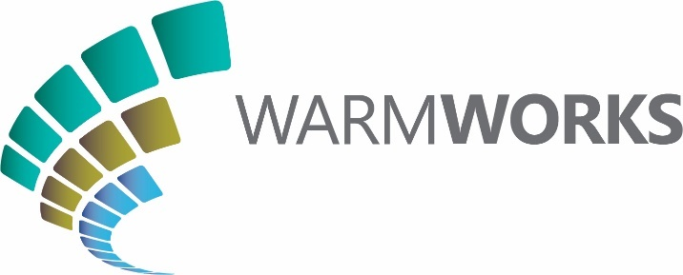

February 2022

PRESS RELEASE: FOR IMMEDIATE USE
NEW INITIATIVE LAUNCHED TO HELP HOMES IN THE EPPING FOREST DISTRICT COUNCIL AREA BE WARMER, GREENER AND SAVE ON FUEL BILLS THIS WINTER
People across the district of Epping Forest are being encouraged to check if they are eligible to receive help under a new scheme being launched to help local householders be warmer in their homes, lower their carbon emissions, and save money on their fuel bills this winter.
Under the Green Homes Grant Local Authority Delivery scheme, delivered by Warmworks on behalf of Epping Forest District Council and through funding from the UK Government, householders can apply to receive improvements to increase the comfort and warmth in their home. The scheme offers a wide range of insulation measures, and renewable heating technologies, such as air source heat pumps, which are designed to reduce the impact of heating homes upon the environment.
The Green Homes Grant scheme is open to homeowners, private tenants and people in social rented accommodation, where the home has a low energy rating and a low annual income.
Warmworks will arrange a survey in the homes of eligible householders to agree what work will be carried out. Then, a local accredited and registered sub-contractor team completes the installation of the agreed heating and energy-efficiency measures, before an independent inspection assesses the completed work against rigorous quality standards. Where required, Warmworks will also then arrange for a full annual service to be completed 12 months later.
Ross Armstrong, Warmworks Managing Director, said:
“On the back of the COP26 conference in Glasgow, I’m delighted that Warmworks is working in partnership with Epping Forest District Council to deliver the Green Homes Grant scheme.
“Not only does the renewable heating technology available under it offer local people an opportunity to reduce their carbon emissions and support the transition to Net Zero, but as the colder weather hits, one of the most important benefits we can offer through the scheme is to help people in the district of Epping Forest to feel warmer, healthier and happier in their homes during these winter months.
“A few minutes to complete our short application could help your home stay warmer for years ahead.”
You can find out if you are eligible for the scheme by completing the short application form at https://www.warmworks.co.uk/greenhomesgrant/ or by calling Warmworks free of charge on 0808 196 8255.
ENDS

Media Contact:
Dan Jones
Public Affairs and Communications Manager
dan.jones@warmworks.co.uk
07884 084 142

Notes to Editor
Green Homes Grant scheme
1. The Green Homes Grant scheme is a UK-Government funded initiative, supporting local projects to make energy-saving improvements in people’s homes. The scheme aims to reduce household fuel bills, make homes warmer and more comfortable, lower carbon emissions and create green jobs.
2. Householders can check if they are eligible for support under the Green Homes Grant scheme by completing a short application form at: https://www.warmworks.co.uk/greenhomesgrant/ or by calling Warmworks free of charge on 0808 196 8255.
3. Warmworks is the Managing Agent of the Green Homes Grant scheme, working on behalf of local authorities across Hertfordshire, Essex, Buckinghamshire and selected areas of London.
4. Improvements offered under the Green Homes Grant scheme are assessed following a survey of the home, carried out by one of Warmworks’ highly-qualified surveyors. Improvements offered under the scheme can include wall, loft and hot water tank insulation; air source, ground source or hybrid heat pumps; biomass boilers; double / triple glazing to replace single glazing; energy-efficient doors; and thermostats and heating controls.
5. The replacement / repair of fossil fuel heating systems, such as gas / oil / LPG boilers is not available under this scheme.
Warmworks
6. Warmworks is a joint venture between the Energy Saving Trust, Everwarm and Changeworks. Warmworks launched in 2015 to deliver the Scottish Government’s national fuel poverty scheme, Warmer Homes Scotland. This scheme provides insulation, efficient heating and renewable technologies in the homes of households who are struggling with the cost of high energy bills, making homes warmer, more comfortable and more affordable to heat. Since 2015, we have delivered energy-efficiency and heating measures to almost 25,000 homes across the country.
7. Warmworks also now manages a number of different schemes across Scotland, from Orkney to the Scottish Borders, all of which aim to support householders to be warmer, happier and more energy-efficient in their homes.
8. Further information on Warmworks is available through our website at www.warmworks.co.uk

